

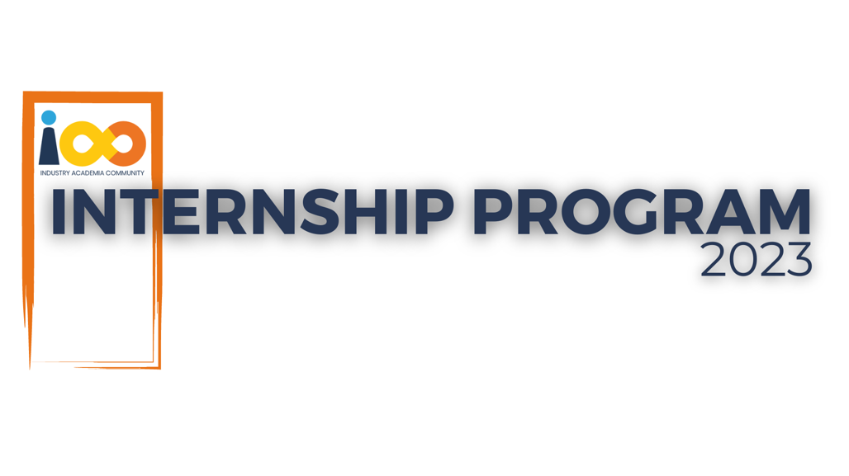

PROJECT REPORT

WEB DEVELOPMENT  
  
COLLEGE FINDER INDIA

|  |  |  |  |
| --- | --- | --- | --- |
| **Created By:** | Abuzaid Inamdar | **Approved By:** | <Domain Lead Name> |
| **Created On:** | 10-07-2025 | **Approved On:** | DD-MMM-YYYY |

Page left blank intentionally

**INDEX**

**1** **PROJECT DETAILS** 2

**2** **SUMMARY** 2

**3** **INTRODUCTION** 2

3.1 Background 2

3.2 Stakeholders 2

3.3 Objectives 2

**4** **METHODOLOGY** 2

4.1 Considerations & Assumption 3

4.2 Approach 3

4.3 Activities 3

**5** **TARGETTED V/S ACHIEVED OUTPUT** 3

**6** **CONCLUSION** 3

**7** **APPENDICES** 4

7.1 Appendix A – Title 4

**General Instructions for using the Live Project Report Template**

* This template and the subsequent document created using this template is a confidential document and is the intellectual property of Cloud Counselage Pvt. Ltd. Circulating it outside of the organisation without the consent of Cloud Counselage Pvt. Ltd. is the breach of company policies and will lead to legal actions
* This template is a guideline document to communicate the implementation of design ideas and the results of the work to the stakeholders.
* The **text between inequality (< >) is to be replaced** by relevant text
* Please **remove the yellow highlight on the Text** between the inequality (< >). This is done to help you notice the text to be changed/replaced
* The text in *italics* highlighted in grey is just for reference and should be removed after adding the relevant text

# **PROJECT DETAILS**

|  |  |  |  |
| --- | --- | --- | --- |
| **Project Name** | College Finder | | |
| **Project Sponsor** |  | | |
| **Project Manager** |  | | |
| **Start Date** | 20-0602025 | **Completion Date** | 10-07-2025 |

# **SUMMARY**

*<Explain what the project was expected to deliver, why the project was needed and what the long-term benefits have been or will be. Even though a summary is placed at the beginning of a project report, you can only write it once your entire report is complete.>*

The project delivers a centralized, ad-free platform to help students find accurate and updated information about IT and Management colleges in India, supporting better decision-making and future partnerships for professional development.

# **INTRODUCTION**

## Background

*<Take this section from the problem statement & the discussion points from requirement elicitation meeting>*

The problem identified was the absence of a centralized, reliable platform for students to search IT and Management colleges in India. From the requirement elicitation meeting, the solution proposed was to build a web application that provides updated, ad-free, and verified information about colleges, courses, and contact details, enabling better decision-making for students.

## Stakeholders

*<Take this section from the problem statement & the discussion points from requirement elicitation meeting>*

The project aims to resolve the challenge faced by students in finding accurate and centralized information about IT and Management colleges in India. Existing platforms are often cluttered with advertisements or provide outdated and incomplete data, making it difficult for students to make informed choices. During the requirement elicitation phase, stakeholders emphasized the need for a **simple, ad-free web application** that allows users to **select a city or state and access up-to-date details** about colleges — including their **contact information, official website, courses offered, and fee structures**. This feedback guided the development of a responsive, API-driven platform focused on clarity, usability, and reliability.

## Objectives

*<Reference the objectives in the* ***Project Charter*** *and describe what has been achieved. If there were any changes to the project objectives since the* ***Project Charter*** *was approved/submission they should be documented here.>*

# The project aimed to develop a centralized web application for students to search IT and Management colleges across India, free from ads and clutter. The frontend was built using **React**, and college data was fetched through **API integration**, eliminating the need for a traditional database. The application provides a clean, responsive interface where users can select a **state or city** and view a detailed list of colleges, including **contact information, website links, and fee structures**. By avoiding user authentication and backend storage, the project focuses on **simplicity, speed, and accuracy**, staying true to its goal of helping students make well-informed educational choices.

# **METHODOLOGY**

These conventions are all about the positions of line breaks, how many characters should go on a line, and everything in between.

## Considerations & Assumption

*<Mention any constraints, challenges and reasons for making the assumptions you made for delivering this project that formed to basis for working on this project>*

The major constraints faced during the project included **limited access to real-time government or verified college data APIs**, time restrictions for development, and the need to ensure a **fully responsive design across various devices**. Due to the absence of a centralized official dataset, we relied on **curated data from trusted public APIs** and, where necessary, **manual integration of static data** to build a reliable MVP. Since no backend or database was used, the project architecture was kept **lightweight and frontend-focused**, allowing for **faster development and easier deployment** using only client-side technologies..

## Approach

*<Mention the structured approach you adopted to solve the problem and why. Keep it conceptual>*

## We adopted an agile and modular approach to address the problem effectively. Initially, we analyzed user needs based on the problem statement and requirement discussions. The project was then broken down into key modules — including the frontend interface, API integration, and data presentation logic. React was selected for its component-based structure and flexibility, allowing us to create reusable UI elements for search, filtering, and college listings. Since we did not use a backend or database, API integration was central to our architecture, enabling efficient data retrieval without additional backend overhead. This structured, iterative process enabled faster development, testing, and user-driven refinement, resulting in a lightweight, scalable, and user-friendly platform.

## Activities

*<Mention the activities you performed to deliver the project. E.g. requirement •* ***Requirement Gathering*** *– Collected detailed inputs from stakeholders through discussions and analysis of the problem statement, identifying the need for a centralized, ad-free college discovery platform.*

*•* ***Planning*** *– Defined the project scope, features, user flows, tech stack (****React*** *and* ***API integration****), and estimated development timelines.*

*•* ***Designing*** *– Created the UI/UX layout using* ***wireframes*** *and planned reusable* ***React components*** *to ensure a clean and responsive user interface.*

*•* ***Development*** *– Built the* ***frontend using React****, with data fetched dynamically from* ***external or manually curated APIs****, eliminating the need for a backend or database.*

*•* ***Testing*** *– Performed functional testing across devices and screen sizes to ensure* ***responsive design*** *and* ***smooth performance*** *of all features.*

*•* ***Deployment*** *– Deployed the web application using a static site hosting platform (e.g.,* ***Vercel****,* ***Netlify****, or similar) for* ***real-time public access and review****.*

# **TARGETTED V/S ACHIEVED OUTPUT**

*<Mention the targeted output in the project plan and against it what you have been able to achieve. Also mention the reason of deviation. Please remember the deviations will not impact the evaluation and the results of your internship. This sections will help you to analyse the results and understand the cause for deviation that will be lessons learnt for you and would help you to perform better in the next project>*

**Objective:**  
The project aimed to develop a fully functional **web application** that enables users to explore **IT and Management colleges in India**, providing detailed information such as **courses offered, contact details, websites, and fees** — all in a clean, ad-free interface. Key goals included a **responsive UI**, efficient **search and filtering**, and a **distraction-free experience** for students.

**Achieved:**  
We successfully built the application using **React** for the frontend and implemented **API-based data fetching** to display real-time information on colleges based on the selected city or state. The core functionalities — such as **listing colleges**, **displaying key details**, and **location-based filtering** — were fully developed and deployed.

**Deviation:**  
Some advanced features, such as **user authentication**, **admin panel**, and **dynamic data management**, were not implemented in this version to maintain a lightweight, frontend-only architecture.

**Reason for Deviation:**  
The primary reasons included **time constraints**, the decision to avoid backend complexity, and the **focus on delivering a minimum viable product (MVP)** using only APIs and static data sources. This helped streamline development and deployment, while also providing insights into **efficient frontend design** and **API handling**.

# **CONCLUSION**

*<Mention the how it will prove to be useful for the stakeholders and what can be the future scope>*

1. **Conclusion**

The project delivers a clean, ad-free, and informative web platform for students and parents to explore IT and Management colleges across India. It simplifies the college search experience by offering quick access to course details, contact information, and city/state-based filters. By removing distractions and focusing on clarity, the application serves as a useful tool during the admission research process.

1. **Future Scope**

* Add user authentication to allow students to save and manage their favorite colleges.
* Include an admin panel to enable dynamic addition or editing of college data.
* Integrate interactive maps and user reviews to help students evaluate college locations and quality.
* Expand the platform to cover other streams such as Engineering, Medical, Law, and Arts.
* Incorporate AI-based recommendation systems to suggest colleges based on user preferences and past interactions.

# **APPENDICES**

## Appendix A – Title

|  |  |  |  |
| --- | --- | --- | --- |
| **Component Name** | |  | | --- | |  |  |  | | --- | | **Description** | |
| State Dropdown | |  | | --- | |  |  |  | | --- | | Check if all states show correctly and selection works. | |
| City Dropdown | |  | | --- | |  |  |  | | --- | | Check if cities load based on the selected state. | |
| Search Button | |  | | --- | |  |  |  | | --- | | Ensure it shows results when state/city is selected. | |
| Responsive Layout | Verify layout adjusts on mobile, tablet, and desktop. |
| |  | | --- | |  |   Loading Time | |  | | --- | |  | |  |  |  | | --- | | Ensure the site loads quickly (under 3 seconds). | |